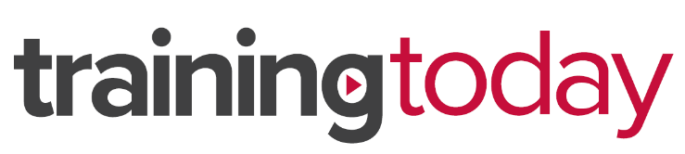
2019 LMS Migration | Frequently Asked Questions

Before migration

What will change for our leaners? The only difference for learners will be where they are accessing courses from. The platform URL will change to reflect the new system. However, the basic workflow will remain the same.
Does the price change? No, the increased functionality of the new LMS does not factor into the pricing of your library.

During migration

What does migration mean? Does it require any work on my end? Migration means we are mapping over all your user data from the old platform to the new system. The data transfer will not require anything from you, however we will ask that your learners check/validate their log in information and course histories during the designated time.
What will happen to my course history records? If I completed courses already, will that move over to the new platform? Yes, all the course completion records will be transferred to the new platform.
What happens if I am in the middle of a course/library during the transition? We will ask that learners finish their current course modules before the designated shut down period. If you are in the middle of a library, you only need to finish that single course to save your progress. For example, if there are 10 courses in a library and you have completed the first 5 courses, that information will carry over. However, if you are still in progress on the 6th course and do not finish, you will have to start the 6th course over once the training is available again.

Post migration

Will our learners have an opportunity to check that their courses and course history are correct? Yes, users will be able to confirm their profile information and that assigned and completed courses are correct.
If a learner reports a discrepancy, will you be able to check and fix the error? Yes. We have copies of all user histories from the current LMS for your organization. We can confirm the error with the file and easily update the user’s profile.
Will learners have accessibility to courses on mobile and tablet devices? Yes. Students can access courses anywhere or any time they have an internet connection.

Who can I contact if I need support?
Please reach out to your sales representative or our Client Success Team at help@blr.com, or call (800) 274-6774 x1565.

